The green house is place where a plant growing under specific conditions that are provide by green house shield and it is fit with plants which will be planted inside the green house. The project is useful to grow a plant without any human resources inside a green because all things control automatically.

This automation project is monitoring the environment conditions, behavior of growth plant. And infections of the plant are analysis using data which are gathering from sensors such as temperature sensor, Humidity Sensor, Light sensor Etc. And infections and growth of plant data is accumulating by using Artificial Intelligent base real time image processing techniques. It is directly connected with the IoT base web application as well as mobile applications. The entire system can be controlled remotely by using above mentioned methods.

Initially. All sensors values are gathered separately and analysis collected data by using specific algorithm which can be control all actuators. Such as light exposing. Lux value. Water from automated irrigation systems. The water irrigation system is manipulating by data which is accumulate from moisture sensor that is place inside a plant. And some infections of the plant are detecting by image processing system. If there is some infection. Web app is generating critical notifications with statically data which are collected from initial state of plant to infected date. And solution that should do is suggest and give it the user. And then if user wants to take detailed report of plants. The app is generating growth vs time graph and all static DAT of that plant from app server.

3. Project Summary: (Describe in brief (less than 200 word) the justification of the proposed study, Procedure(s)/ hypothesis to be addressed, experimental/ research design, analytical and statistical methods and expected outcomes/outputs )

SECTION C: Research Proposal & the Detailed Budget

- Justification of the proposed research project This section should include a comprehensive write up on the issue/problems, existing knowledge based on local and international published literature and/or on-going preliminary findings or scientific revelations which merit further investigations. All statements must be adequately back by published literature. All publication cited in the text must be listed under references. (Attach additional sheets if necessary)
a) Text:
b) Reference List:

2. Originality & innovativeness of the proposed work

[If your proposed work is claimed as original and innovative, pl. qualify it by presenting evidences for your claim and the argument (s)]

- General and specific objectives of the proposed work

Controlling climate conditions are one of the most critical challenge in greenhouse system. Using our proposed system, it developed to accomplish observations and controlling of the climatic parameters.

Specific objective is to design a simple, easy to install, microcontroller-bases circuit to monitor and record the values of temperature, soil moisture and sunlight of the natural environment. That are continuously modified and controlled in order to optimize them to achieve maximum plant growth.

The proposed system makes to be an economical portable and low maintenance solution for greenhouse applications.

Not only that, especially in rural area and for small scale agriculturist can use this proposed system easily.

The proposed system consist of a sensor that continuously takes data from the greenhouse environment and report it.

It focuses on saving water, increasing efficiency and reducing the environment impact on plant production.

The user can see the atmospheric conditions of the greenhouse plants on the web app and control the greenhouse for far way places.

3.1 General Objective/s
3.2 Specific Objective/s

- Methodology (Attach additional sheets if necessary)
In this page introduces the methodology behind the project.
In case of hardware implementation, the sensors-temperature sensor, soil measure sensor, methane sensor was connected with the ATmega328p microcontroller with the monitor driver module and the power was supplied with the help of a solar panel. In below flow chart shows the entire project. The sensors sensed the parameters such as temperature, methane quality, soil measure and the microcontroller sensed the values from them and display onto the web app and also the LCD screen and according the control actions were done that were needed. In case of temperature sensor, if temperature is increased the greenhouse, the door was closed manually.
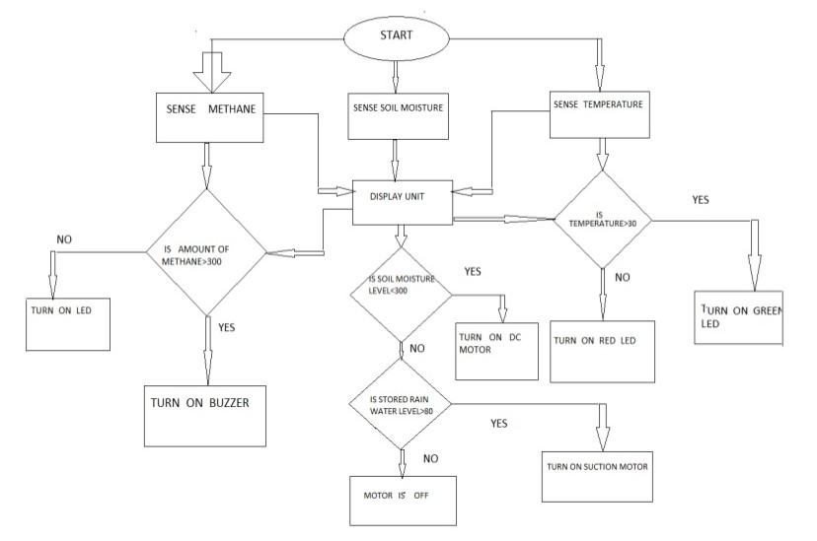

Pl. Describe in sufficient details of the Methodology of the proposed study

4.1 Experiential Layout and Design (If applicable)
4.2) Methodology in details, where applicable

Please complete relevant sections
- Data/Sample collection
b) Study group vs. controls
c) Other methods used to create data
d) Validation and quality control of methods
e) Cost effectiveness of proposed methodology with regard to applications/developments

